Briana and the Explosion of the Dishes
By Briana Wink
Dedicated to Peter Wink

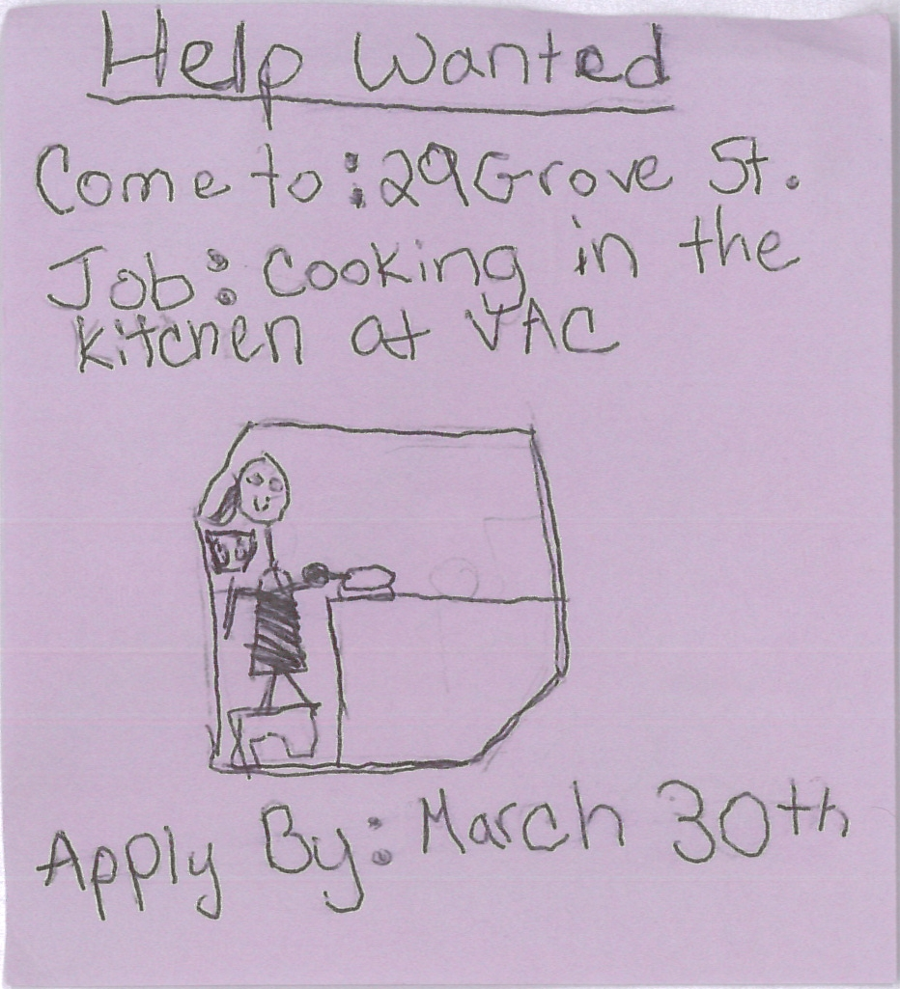
I was walking down the brand new sidewalk, on a warm Spring day, when I saw the sign, HELP WANTED if interested in cooking apply at 29 Grove Street. Apply by March 30th. I thought for a second Hmm I can use the money, and I enjoy cooking, I took out the sticky notes in my bag and wrote down the address and ran home.

“DAD” I yelled.

“What do you want Briana?”shouted my Dad.

“I found an opening for a job, so can you give me a ride to 29 Grove Street”I asked.

“No, I can’t. You are going to have to walk there.”

“Dad it is 10 miles on foot across town,” I exaggerated.

“ Can you wait until tomorrow?” Questioned my Dad.

“I guess. It’ll give me time to type up my resume and take a shower,” I sighed.

I went to my room, typed up my resume, showered, and picked out my favorite jeans and Timmy Timato t-shirt for the next day.I tried to go to sleep early when,BANG! It struck me. I should look to see when the job posting was put up so I know if someone took the job yet. Then I grabbed my laptop off of my desk, turned on my light, and looked online.

“Oh my gosh!” I thought “The help wanted sign was put up three days ago,” There was only one thing for me to do- email them to see if someone took the job.Then I started my email …

Dear VAC Kitchen staff, my name is Briana. I am wondering if someone got the job that you guys advertised. If not please write me back. I am sixteen years old. Again, please write me back.Thank you, Briana…

Then I went to bed happily but sleepily.

Morning came and I awoke to the smell of coffee brewing in the coffee pot, a few feet away from my room, in the kitchen. Mmmm I thought. I go to grab my laptop to check to see if the Kitchen staff have e-mailed me back yet. Yes! I thought. Then I read the email…

Dear Briana,
No one has taken the job.
You just need to tell me your weaknesses in the kitchen.The job is almost yours.

Thank you, Patty and Sue Ellen.

“DAD” I yelled, “Can you take me to the job interview now? It’s already eight o’clock.”

“Yes I can, just wait a couple of minutes and then I can bring you.” He answered.

“Okay.” I bellowed.

I threw on my clothes, did my hair, put on my shoes and left to VAC with my Dad.

“EEEE, we’re here. I am so excited for my first job,” I screamed and jumped out of the car and started running toward the VAC building.

A few seconds later my Dad shouted out of the window, “Remember to be kind.”

“I will” I thought. I got to the VAC door, wiped off my shoes on the old doormat, and I immediately heard kids screaming, teachers yelling,and toys hitting walls as I walked into the lobby.

“Oh jeez,” I muttered to myself.

As I walk through the door I saw a phone on the wall, so I picked it up, looked on the wall space above and found the Kitchen’s number and called it.

“Hello, Sue Ellen speaking. Who is this?” asked the voice on the phone.

“ Hi, I’m Briana, the person taking the open job spot,” I answered into the phone.

“ Oh yes, I will come to the lobby right now,” answered the voice on the phone.

“Okay, I’ll hold tight.”I replied and hung up the phone.

I waited a few minutes and then a door slammed and a woman approached me.

“Hello, I’m Sue Ellen,”Claimed the woman pacing in front of me.

“I’m Briana. I’m here to take the job opening,”I stated.

“You already told me that on the phone,” snapped Sue Ellen.

“ I’m sorry. I’m just very nervous. It is my first job interview.” I responded.

“Follow me to the Kitchen.” Stated Sue Ellen. She started walking down the hall.

I followed Sue Ellen to the Kitchen nervously.

“That is the Club House where the oldest kids hang out, next is the Blue Room where the people go if there are too many people in one room, right up there is the Rainbow Room where the youngest people go, down that hall is the Office, but we aren’t going down that way right now,” explained Sue Ellen while we walked, “ Next is the Brown Room where the pre kindergarteners go, Black Room where the pre brown room kids go, and Indigo Room where the autistic kids go, do you have any questions?” She stopped walking.

“Yes why do I need to know where all of the rooms are?” I questioned.

“You need to know where these rooms are so you can take the carts to the rooms for lunch and snack,” Sue Ellen answered in a matter of factly tone, and we started walking again.

“Oh that makes more sense,” I claimed.

We walked into the Kitchen and there was a woman, with short dirty blond hair and she was wearing an apron, who stood in the Kitchen doing the dishes.

“Sue Ellen, I thought you said no one took the job yet,” I whispered while approaching Sue Ellen .

“She didn’t take the job opening, she is my job partner, and we were looking for someone to help us when one of us is out, and someone to help us on a daily basis,”Explained Sue Ellen, “She is Patty.”

“Sue, who is this young girl?” Yelled, Patty over the roar of the old dish washer.

“This is Briana,”Sue Ellen yelled back over the same roar.

The roar stopped and everyone was quiet.

“Sue Ellen, can I call you Sue?” I asked.

“Yeah sure,” replied Sue Ellen.

We started the recipe: “Two cups of milk. Check. One cup of sugar. Check. One fourth cup of powdered milk. Check. Eight egg yolks. Check. One cup of heavy whipping cream. Check. One teaspoon of vanilla extract. Check. Three cups of strawberries. Check”, I thought.

“What are we making??” I asked while approaching Patty.

“Strawberry ice cream.” Said Patty, she looked down and popped a strawberry into her mouth.

We finished putting all of the finishing touches into the ice cream and put it into the freezer.

“Oh crud,” I started while feeling a rise in my temper, “I used sea salt instead of sugar.”

“Are you kidding me?”Replied Patty. “Well none of the children have to eat it. It’ll be fine.”

“No it isn’t” I thought to myself, “I messed up the whole recipe and now I’m getting told that it’s okay when is isn’t.”

“Why did we make the ice cream?” I asked, while I popped a strawberry into my mouth.

“It is part of the interview,” replied Patty.

The day passed by and I kept thinking about the mess up in the ice cream, and then it happened. “This is bad,” I thought

“ Briana come here. You have to taste this ice cream,” said some voices in the corner of the kitchen.

“Oh no,” I thought, “I messed up the whole recipe and now I have to eat it.”

I walked over to Sue Ellen and Patty. Then I grabbed the bowl that was prepared for me.I keep doubting myself about the taste. I grabbed the spoon and took a small spoonful of ice cream into my mouth. The flavor hit my taste buds, and I immediately regretted the taste. I swallowed hard and took another spoonful of this horrible ice cream I had made.I managed to get through my bowl without spilling the truth.

The time came for me to leave so I did. I still regretted the taste of the ice cream. I just kept thinking about what time I had to come into work the next day at 5 o’clock. I kept thinking about that because it was the only thing that kept me from thinking about the ice cream. I opened. I started the day. Worst of all I had to come in three hours before my bosses.

I got home and I saw my laptop on the floor. It was opened from this morning and my B-mail was blinking.It was an email from Sue…

Briana,
You didn’t tell me about your weaknesses in the kitchen.

Your boss, Sue Ellen…

I replied to her email with one word, stress. I kept’ thinking about the ice cream that I messed up.

“Dad I am going to the store down the road.” I yelled.

He didn’t answer, so I wrote a note. I started walking to the store down the street. I went into the store and bought the ingredients to make the ice cream. I walked home and placed out all of the ingredients onto the counter. I made the ice cream and froze it.I went into my room and waited 4 hours for it to freeze and then I went and grabbed the ice cream. I turned on the tv and watched Jr Master Bakers.The ice cream tasted a lot better. I watched two episodes and then went to bed.Two minutes later my dad came home.

“I bought you a new car!!!!”Yelled my Dad,”I got it for you while you were at work.”

I ran out to living room and hugged him.

“Thank You so much!”I squealed.

“It is a brand new Jeep!” Yelled my dad as he tossed me the keys and pointed out of the window.

“Yes!” I screeched.

Later I went to bed with so much excitement that I woke up at two am. I thought to myself, “ I should open early.” I pulled on my uniform and headed out the door. I showed up, made the ice cream, froze that.Then I started making lunch at 5:30am.

“Cheese on bread, cheese on bread.”I chanted to myself.

I thought for a second, “What would make this job more fun?”

“Oh I know, I can…” I got cut off by my thoughts.

“I can go to the fridge and grab the bread dough,”I softly commanded myself.

I came back with the bread dough,at 7:30 a.m., took it out of the container, put the dough into the pan, and plopped the pan into the oven. I waited one hour and then grabbed the freshly baked bread out of the oven. Two minutes passed then Sue and Patty showed up.

“Hi” I warmly welcomed them, “why are you here so early?”

“We are here to check on you,” answered Patty.

“Okay,” I replied nervously, “Do you want some freshly baked bread?”

“Oh, yes, please. That sounds delightful,” Replied Sue.

I cut them some bread and they left to go to the break room. I had hoped they went there because they trusted me.

I started breakfast. I put the pre made pancakes onto the tray and plopped them into the oven. I grabbed the plates then ten minutes later I grab the pancakes out of the oven and started to plate. Twenty minutes passed and then the kids started piling in. I gave them the breakfast and I got called.

“Hi Briana,” Said the voice on the phone.

“Hi,” I replied.

“You need to put food on the carts and go to the rooms who don’t show up.”

I hung up the phone and went straight to work.

I brought everything to where it goes, without a problem, and the dishes started piling in. I thought that I should pile the racks on top of eachother. I did that a few times and then pewwwwwww. What was going on?
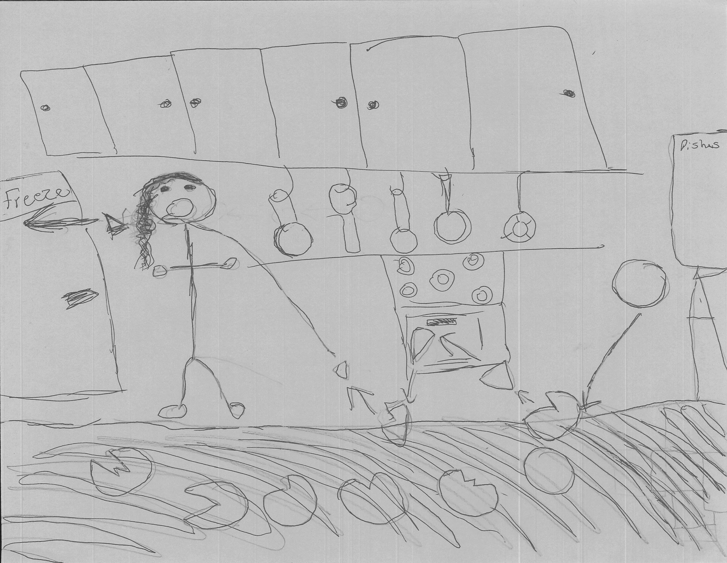
Dishes went everywhere. Shards of plastic started smashing off of walls. A white piece of plastic whizzed past my face (add my picture)and I jumped. It’s a good thing that I am done for the morning and that my bosses were still sleeping. I grabbed the broom and started cleaning up the mess. I scrubbed the floors and the sinks. Before I knew it I had to start lunch. I put the premade grilled cheeses into the oven. I really hoped that everyone could just eat grilled cheese. I served lunch without a problem and then I gave out the ice cream that I made. I washed the rest of the plates by hand and went to the office and told the director of VAC that the dishwasher broke down. They said that it was okay and that they would replace it as soon as I could.

I cleaned the rest of the dishes up and drove to Walmart. I grabbed some of the plates, 100 to be exact. I drove back to VAC and put all of the plates in the cupboards and drove home. I went to bed and then opened the next day. I had a feeling that I was going to run that kitchen some day. I ended up falling in love with this job and cooking for the rest of my life.

THE END

